Overview on Point Cloud:

* Point clouds are essentially the simplest form of 3D models. **They are collections of individual points plotted in 3D space.**
* Each point contains several measurements, including its coordinates along the X, Y, and Z-axes, and sometimes additional data such as a color value, which is stored in RGB format, and luminance value, which determines how bright the point is.
* How is it created?
* Point clouds are created by performing a scan of an object or structure. Scans are completed by using either a **laser scanner** or through a [process called **photogrammetry**](https://www.dronegenuity.com/aerial-photogrammetry/).
* Where is it used?
* Point clouds can either be directly rendered and inspected or converted into models using various shapes and patterns.
* The primary purpose of a point cloud is to [**create a 3D model**](https://www.dronegenuity.com/services/drone-3d-model/)**.** The point cloud itself can be experienced as a 3D model, but often the point data is first converted into a polygon mesh because most 3D software programs work with polygons.
* Examples of 3D point cloud processing software:
  + CloudCompare, MeshLab, GOM Inspect.

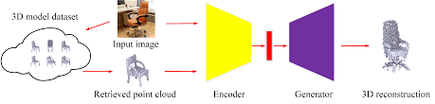

Reference: <https://blog.hexagongeosystems.com/all-you-need-to-know-about-3d-point-clouds/>